**HYPERTENSION DETECTION USING AI PREDICTION**

***By Rachel Nderitu & Ashley Muiru***

***Problem definition***

***Hypertension*** (also High Blood Pressure) is a significant risk factor for cardiovascular diseases such as heart attacks and strokes. It often goes undetected due to its asymptomatic nature, leading to severe health complications if untreated. *Early detection and management of hypertension* are crucial to prevent these adverse outcomes. Henceforth, the ***main objective*** of this project is to develop an AI-driven predictive model that can accurately detect hypertension using patient data, *facilitating early intervention and improving patient outcomes*. It is to be integrated with medical facilities’ systems to help medical personnel with early-on hypertension detection in their patients.

***Objective***

*Our objective*, therefore, is to develop a prediction model that's AI-driven. The work of this model would be to use patient data (medical history, age, weight, etc) to predict whether a patient is a strong candidate for hypertension or not. This will be platformed on a sort of application that can then be used by medical personnel to enter patient data and access their patients' diagnosis. Thereafter, the doctor can be able to recommend a change in lifestyle and/or a referral to a nutritionist.

***Benefits***

In term of ***benefits***, *early detection* is the biggest one as one can be able to get timely medical intervention before further complications occur. *Personalized treatment* is also another great advantage as one, through provision of individualised risk assessments, can acquire an effective treatment plan. Lastly, *efficient resource allocation* is achieved as healthcare workers can be able to prioritize high-risk patients (like in the case of COVID-19, a model like this would have been able to flag which patients are more at risk compared to others).

***Design***

***Selected AI techniques***

For this project, we have chosen Machine Learning (ML) to be the primary AI technique to create at least five different models that can learn from our chosen Kaggle hypertension dataset and make almost-accurate predictions. Supervised learning algorithms will be then used to classify whether patients are hypertensive or not.

**Models**

The following is a list of the ML models we are using:

* ***Logistic Regression***
* ***Decision Tree***
* ***Random Forest***
* ***Gradient Boosting***
* ***Support Vector Machine (SVM)***

***System Architecture***

Here we have several stages: data collection, data preprocessing, model training, model evaluation, and deployment. Below you will find a diagram with the summarized breakdown of the system to avoid repetition as we covered this in the First Stage paper.

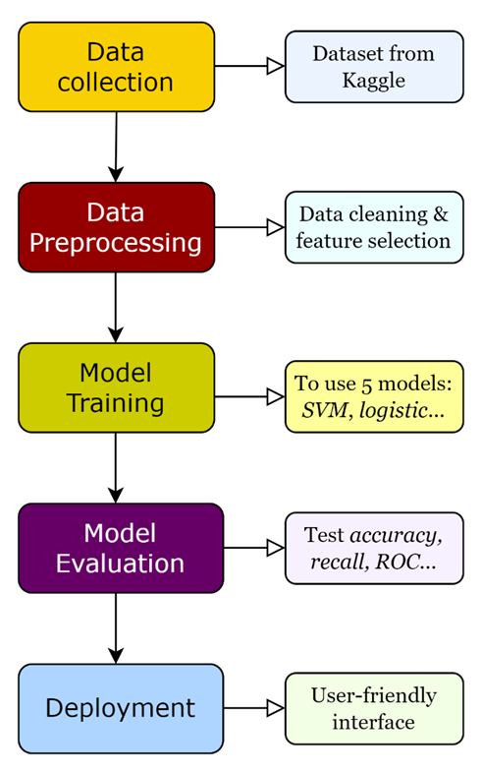

***Development & Testing***

1. **Data Collection**
   * We’ve already ***loaded and prepared*** the hypertension dataset from Kaggle, which includes patients’ clinical measurements; key features such as age, weight, BMI, Blood pressure readings, etc.
2. **Data Preprocessing**
   * ***Data cleaning*** has already been performed by removing any missing values by using the *SimpleImputer* with the mean strategy from the Kaggle dataset.
   * ***Normalization*** has also been achieved by standardizing the features using *StandardScaler* to ensure consistency in our data.
   * ***For our key features,*** we will use those belonging to the dataset: age, sex, cholesterol levels, etc.
3. **Model Training & Evaluation**

* After cleaning the dataset, we ***created, and trained*** our chosen models and ***evaluation*** was done using the metrics *Accuracy*, *Precision*, *Recall*, *F1* *Score*. Our results are as shown below:
* **Logistic Regression:** The performance is as seen below.

Logistic Regression Performance:

Accuracy: 0.8558558558558559

Precision: 0.8371356147021546

Recall: 0.9173611111111111

F1 Score: 0.8754141815772035

* **Decision Tree:** The performance is as seen below.

Decision Tree Performance:

Accuracy: 1.0

Precision: 1.0

Recall: 1.0

F1 Score: 1.0

* **Random Forest:** The performance is as seen below.

Random Forest Performance:

Accuracy: 1.0

Precision: 1.0

Recall: 1.0

F1 Score: 1.0

* **Gradient Boosting:** The performance is as seen below.

Gradient Boosting Performance:

Accuracy: 0.9842821544949204

Precision: 0.9723160027008778

Recall: 1.0

F1 Score: 0.9859637110578569

* **Support Vector Machine (SVM):** The performance is as seen below.

SVM Performance:

Accuracy: 0.984857197623155

Precision: 0.9801165581076449

Recall: 0.9927083333333333

F1 Score: 0.9863722615145766

1. **Deployment**
   * 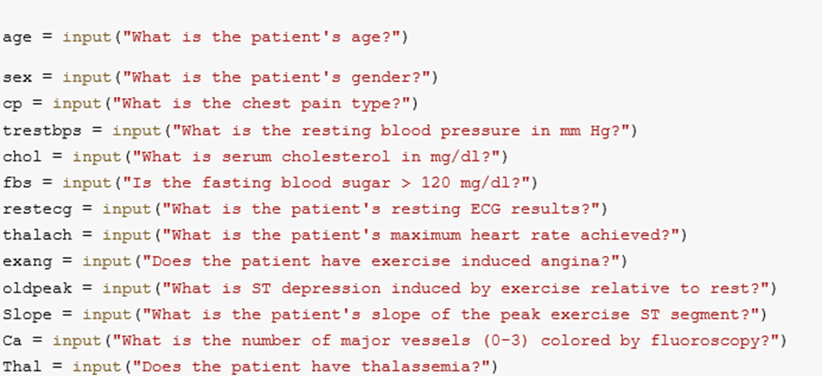***Colab Notebook*** is the first phase of the Deployment Stage. Here, we have interactive questions that are shown below.

You also have the option of running the cell to be able to enter values so as to find out whether someone has a high chance of getting hypertension or not. If you’d like to attempt, remember to enter the data as shown below:

Furthermore, after entering the data, run the very last cell of the ***Notebook*** to get the prediction of whether you have a high chance of getting HBP or not. The result will be as shown in the image below:

* + ***WIX website*** is the second and last phase of the Deployment Stage. Here, we have a mock website has 3 pages starting us off with the Home page (which is supposed to be the Login page). This will be where medical practitioners can login with their credentials to access the second page.

The Form page; where medical personnel can enter their patients’ medical data into a form and submit it so that the AI prediction system in the backend can work on giving the prediction from the data given. In our website form, however, not all the variables are included.

And lastly, the Treatment page. Since the model prediction is taking place in the backend, after submitting the form, the results will appear here as either a High chance of HBP or Low. If it’s High, then there will be a final section where the doctor can enter the patients’ contact info to send them recommended treatment plans, if the patients wish.

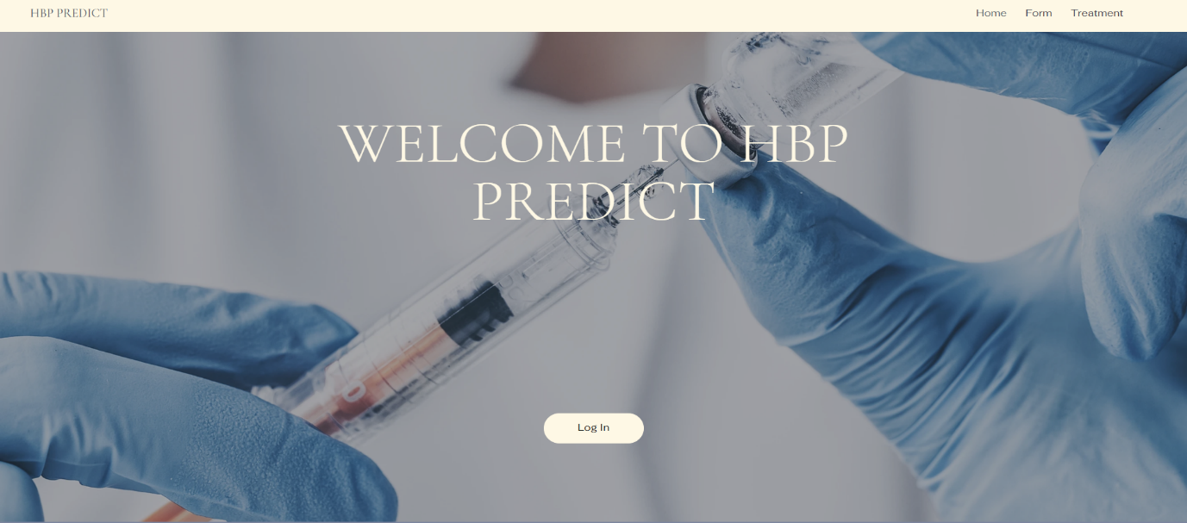The following are photos of the mock website we built. The pages are in chronological order:

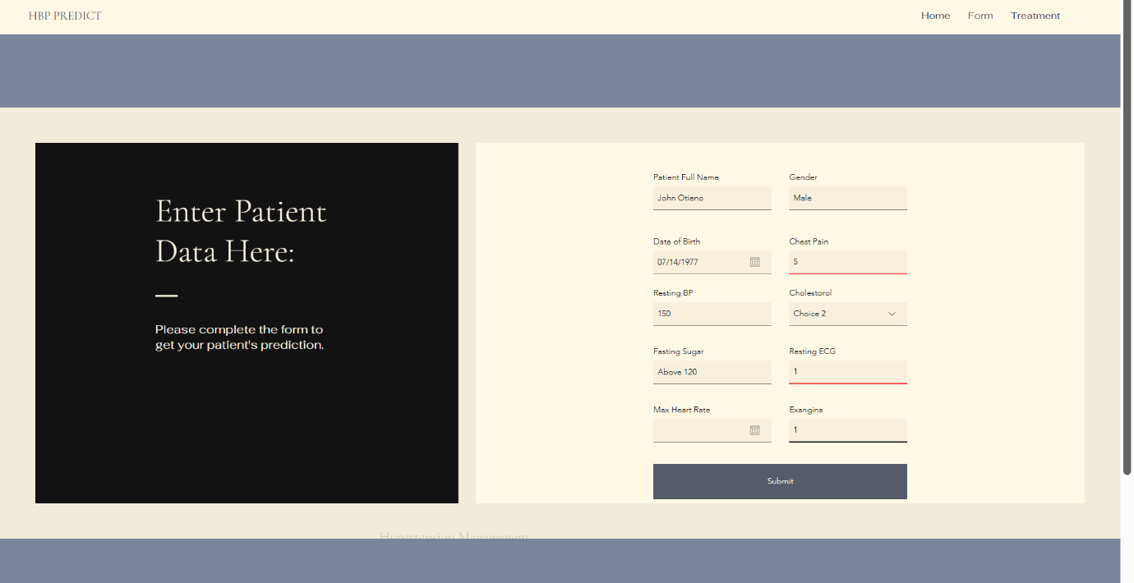

**NOTE:** The website isn’t actually functioning, hence why we’ve termed it a mock website.

***Contributions to SDG 3***

**Early Detection & Prevention**

* By providing doctors with a tool to predict the likelihood of hypertension in patients, our web interface can facilitate *early detection*. This allows for **timely intervention**, which can prevent the onset of more severe cardiovascular diseases such as heart attacks, strokes, and kidney disease. This directly contributes to better health outcomes and ***reduces mortality*** ***rates*** associated with these conditions.

**Improved Patient Outcomes**

* *Our website* can help doctors tailor their treatment plans based on the predictive insights provided.

**Personalized treatment** can improve patient adherence to medication and lifestyle changes, leading to better health outcomes.

The tool can also be used for *continuous monitoring and follow-up*, ensuring that patients at risk of hypertension are **regularly checked and managed** appropriately.

**Education and Awareness**

* *The website* can also be an **educational tool** for patients, helping them understand their risk factors and the importance of managing their health proactively. Increased awareness can lead to better health-seeking behaviors and lifestyle changes.

**Supporting Health Policies**

* Lastly, the website aligns with *global health initiatives, i.e., (Target 3.4:* *By 2030, a one-third reduction in premature deaths from NCDs is targeted through prevention and treatment efforts, alongside the promotion of mental health and well-being. (World Health Organization, 2024)* focused on non-communicable diseases (NCDs) management and prevention. By contributing to the reduction of hypertension, our tool would support the broader goals of **reducing NCDs globally**.

**Enhanced Healthcare Quality**

* Providing doctors with advanced tools and predictive analytics like our web interface will *empower* them to make informed decisions and **improve patient care quality.** This aligns with SDG 3 Goal 3.8*: Achieve universal health coverage, including financial risk protection, access to quality essential healthcare services, and access to safe, effective, quality, and affordable essential medicines and vaccines for all. (World Health Organization, 2024)*

By providing a tool that enhances the quality of healthcare services, we’d be supporting the achievement of universal health coverage.

***REFERENCES:***

World Health Organisation. (2024). *Targets of Sustainable Development Goal 3.* https://www.who.int/europe/about-us/our-work/sustainable-development-goals/targets-of-sustainable-development-goal-3